**CHECKLIST: Steps for Determining your CWC Reporting Requirements**[1]

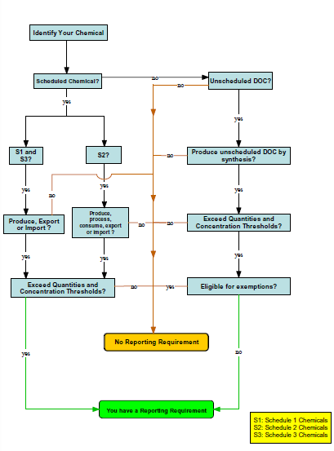

1. Image from: “Global Chemical Industry Compliance Programme (GC-ICP),” CWC, December 2006.